**TR-4165S – RZR RS1 STAGE 5 DUAL SLIP ON**

**INSTALLATION INSTRUCTIONS**

Beginning with the muffler, completely remove the OEM exhaust system and factory heat shield from the vehicle. Heat shield will no longer be used. Place all OEM mounting hardware to the side, as a few components will be used during the installation of the Trinity Racing exhaust system.

Loosely Pre-assemble the mufflers with the supplied billet aluminum double mounting clamps as seen in (Fig. 1).

Using the 8mm x 60mm Allen bolts, Nylocks, Washers, Billet Spacers, Square Washers, and long Billet mounting plate with Trinity Logo (RS1 plate is notched for clearance), Install the mufflers to the vehicle (see Fig. 2).Note the alignment of the mounting bolt, washer, spacer, bracket, block, and locknut in (Fig.3)

Install the 2 into 1 Slip on collector onto the mufflers and OEM headpipes using the OEM Bell gasket and bolts (the springs will not be utilized on the OEM bolts, so remove them prior to install)

Once all springs have been installed, torque all mounting hardware to OEM specifications. All mounting hardware should be re-torqued following the first couple hours of riding.

Before starting the vehicle, clean all stainless steel sections of the exhaust system with carb cleaner, brake cleaner, or stainless steel cleaner to remove all oil and finger prints from installation

**WARNING**

*Trinity Racing exhaust systems will require adjustment to OEM fuel settings such as jetting changes or installation of an EFI programmer. Trinity Racing will not be held responsible for damages that occur during operation of your vehicle under improper fuel settings. Ultimately, it is the responsibility of the owner/rider to adjust fuel settings to specific riding conditions and elevation changes before riding.

*Inspection of the muffler packing is recommended following every 15 hours of runtime. Failure to maintain muffler packing will result in power loss, increased sound output, and damage to the muffler body or muffler components.

*Trinity Racing exhausts systems are designed for high performance applications and are legal for closed course competition only. This product is not applicable nor intended for use on emissions controlled street, highway, or off-road vehicles.

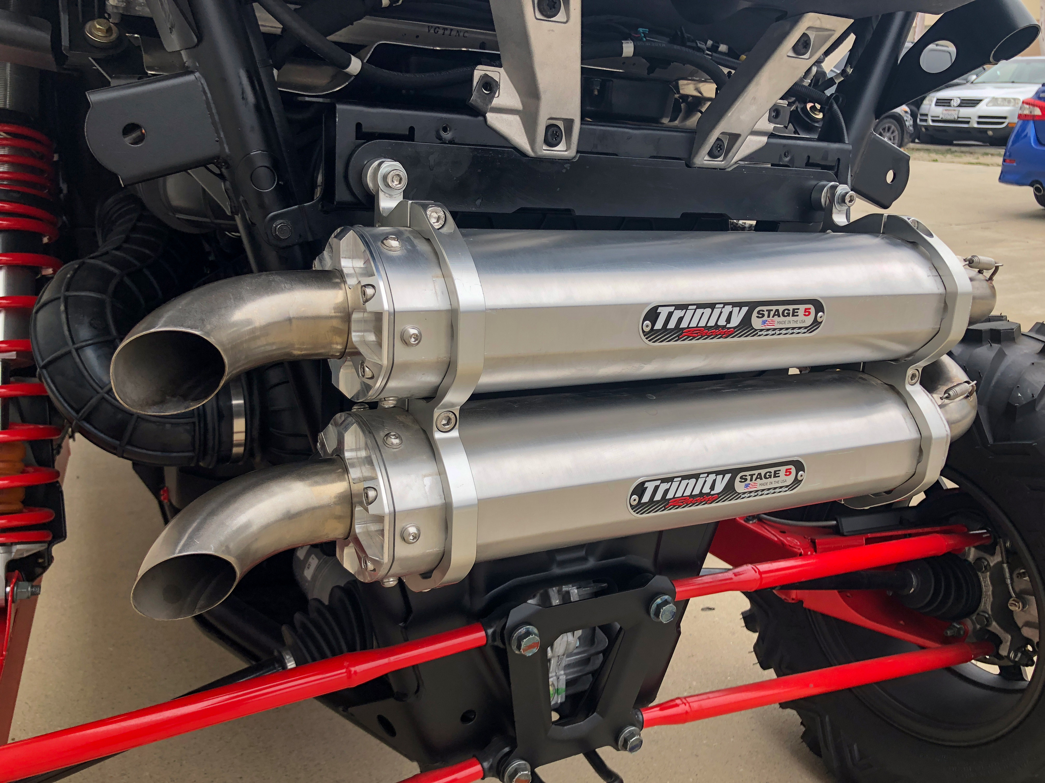

**(FIG. 1)**

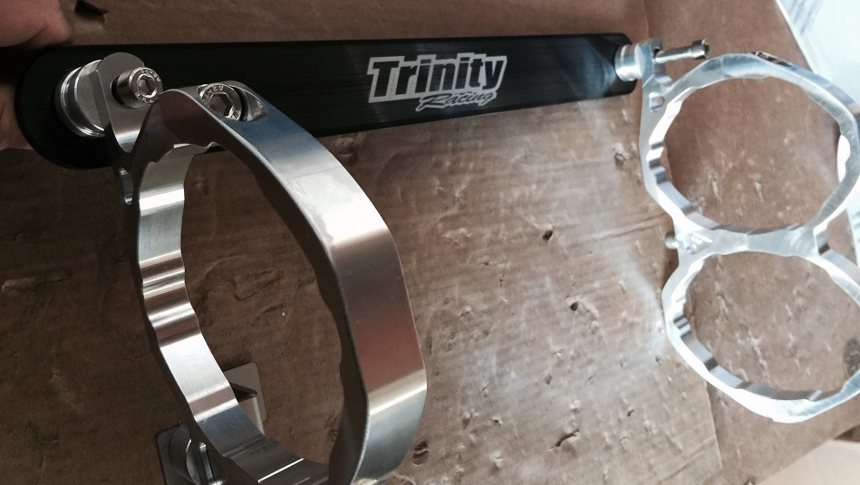

**(FIG 2)**



**(FIG. 3)**

